CASE STUDY ON WEATHER MONITORING USING INTERNET OF THINGS WITH RESPECT TO IoT DESIGN METHODOLOGY

Beulah Evanjalin A

2nd Year, Department of Computer Science,

Central University of Tamil Nadu, Thiruvarur, Tamil Nadu, India.

E-Mail: beulah19@students.cutn.ac.in

Introduction:
Internet of Things is enhancing value to all the web-applications in recent years. The connectivity of the IoT devices over the network has broadly reduced the power utilization, robustness, and connectivity to access data over the network. IoT controlling numerous frontiers of industries and is viewed as a promising technology to take Big Data Analytics to a level higher.
The case study proposed here is a solution for weather monitoring that uses IoT to make its real-time data easily accessible over a very wide range. This system deals with monitoring weather and climate changes like temperature, humidity, wind speed, moisture, light intensity, UV radiation, Air Quality Index (AQI), and even carbon monoxide levels in the air using multiple sensors and are visualized in graphical means. These sensors send the data to the web page and the sensor data is visualized graphically. The data uploaded to the web page undoubtedly be available from anywhere in the world. The information gathered in these web pages can also be utilized for future references. This case study can be of great use to meteorological departments, weather stations, and even the agricultural industry.

Steps involved in IoT Design Methodology includes:
- Purpose & Requirements Specification
- Process Specification
- Domain Model Specification
- Information Model Specification
- Service Specifications
- IoT Level Specification
- Functional View Specification
- Operational View Specification
- Device & Component Integration
- Application Development

Step 1: Purpose and Requirement Specification
The first step in IoT system design methodology is to define the purpose and requirements of the system. In this step, the system purpose, behavior and requirements are captured.
System purpose: To develop a smart and affordable weather monitoring system along with the facility of storing and displaying the weather parameters like temperature, humidity, wind speed, moisture, light intensity, UV radiation, etc in the internet.
Behavior: The system monitors the weather conditions and updates the information to the internet. The purpose for sending the information to the internet is to know the weather states of a specific place and can be known anywhere in the world. This system consists of temperature sensor, Co2 sensor, Humidity sensor etc.. These sensors can check the relating weather parameters. Also the system is incorporated with a microcontroller to process every tasks of the sensors. The wireless communication standard was picked in this system by examining the necessities of the application that the weather conditions should have to be checked and refreshed all the time consistently.
System Management Requirements: System should remotely manages monitoring and controlling the natural conditions like temperature, relative humidity, light force and CO2 level with sensors and sends the data to the internet.
Data Analysis Requirements: System stores the data over the internet. Data collected will also be made available to download in CSV format and perform post processing of data to predict the weather.

Step 2: Process Model Specification
The second step in the IoT design methodology is to define the process specification. In this step, the use cases of the IoT system are formally described based on and derived from the purpose and requirement specifications.
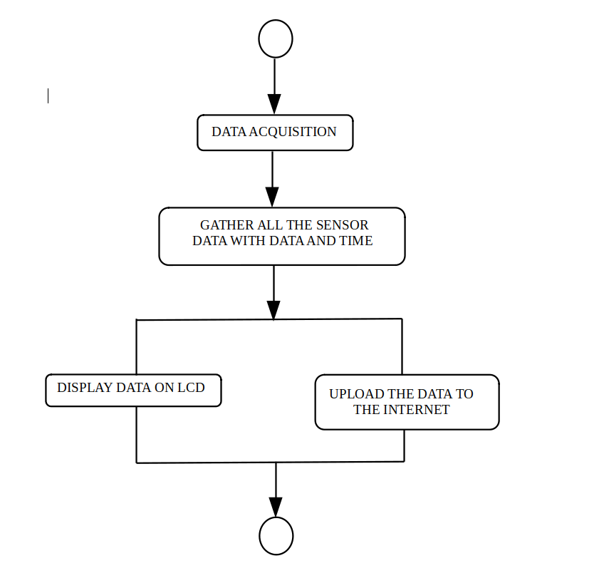

Step 3: Domain Model Specification
The third step in the IoT design methodology is to define the Domain Model. The domain model describes the main concepts, entities and objects in the domain of IoT system to be designed. Domain model defines the attributes of the objects and also the relationships between them. With the domain model, the IoT system designers can get an understanding of the IoT domain for which the system is to be designed.
Physical entity: Soil (whose moisture content is to be monitored)
Virtual entity: Representation of physical entity in digital world. For each physical entity there is a virtual entity.
Devices:
- Raspberry PI 2 model B
- LM35 analog temperature sensor ▪
- Soil Moisture analog sensor (Hygrometer)▪
- Carbon monoxide levels in the air using MQ7
- Water level detection analog sensor ▪
- DH11 air temperature and humidity sensor ▪
- Wind speed using an Anemometer
- UV radiation using a GY8511 solar sensor
- MCP 3008 analog to digital converter ▪
- LCD 16x2 display ▪
- Wireless access adapter (WIFI ROUTER - ESP8266 NodeMCU)
Service: This system provides a values of air quality, humidity, and temperature, wind speed, carbon monoxide level,..etc. MQ7 is used to measure air quality, DHT 11 is used to measure humidity and temperature, GY8511 is used to measure the amount of UV radiation, Hygrometer is used to measure moist of the soil, LM35 to measure temperature and Anemometer to check the wind speed. All the measured values measured by sensors are processed by Node MCU and uploaded into the Internet using ESP8266

Step 4: Information Model Specification
The fourth step in the IoT design methodology is to define the Information Model. Information Modeldefines the structure of all the information in the IoT system, for example, attributes of Virtual Entities, relations, etc.
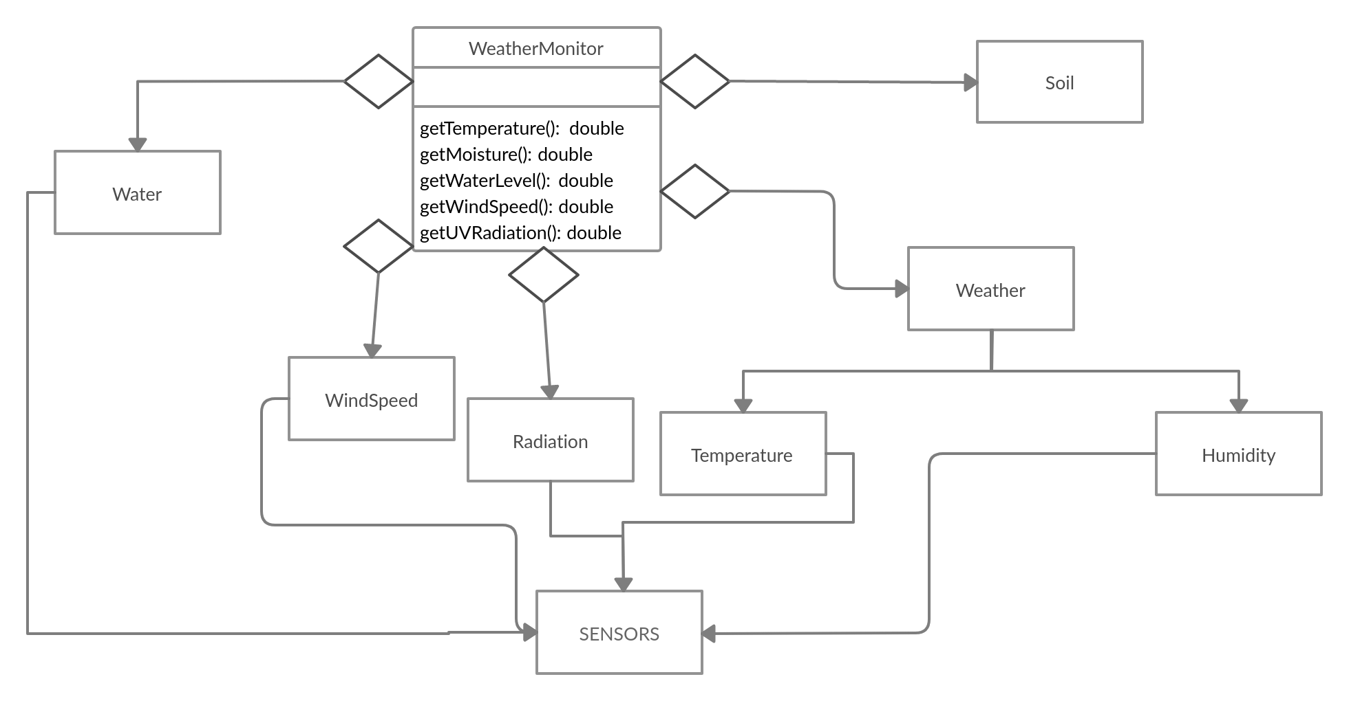

Step 5: Service Specifications
The fifth step in the IoT design methodology is to define the service specifications. Service specifications define the services in the IoT system, service types, service inputs/output, service endpoints, service schedules, service preconditions and service effects.
The services provided by our weather monitoring system are:
- The temperature is read from the racks in a data center.
- Data is read to ESP8266 NodeMCU.
- Rasperry device to store it on a Cloud Database.
- Data is monitored to keep the temperature in check.
- Data is monitored to keep the humidity in check.
- Data is monitored to keep the UV radiation in check.
- Data is monitored to keep the water moist level in check.
- Data is monitored to keep the wind speed in check.
- Data accessibility on the internet
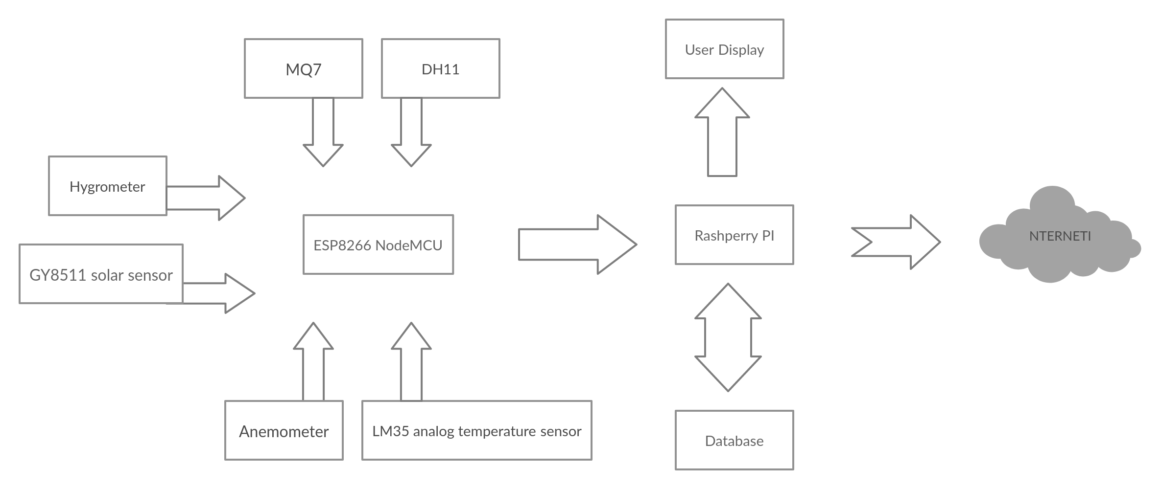
INTERNET

Step 6: Iot Level Specifications
The sixth step in the IoT design methodology is to define the IoT level for the system.Our Weather Monitoring System comes under Iot level-6 System.
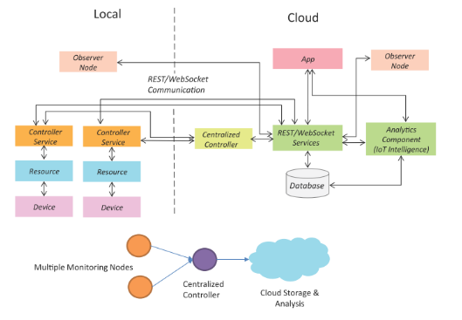

Iot Level 6:
- A level-6 IoT system has multiple independent end nodes that perform sensing and actuation and send data to the cloud.
- Data is stored in the cloud and the application is cloud-based.
- The analytics component analyzes the data and stores the results in the cloud database.
- The results are visualized with the cloud-based application.
- The centralized controller is aware of the status of all the end nodes and sends control commands to the nodes.

Step 7: Functional View Specification
The seventh step in the IoT design methodology is to define the Functional View. The Functional View (FV) defines the functions of the IoT systems grouped into various Functional Groups (FGs). Each Functional Group either provides functionalities for interacting with instances of concepts defined in the Domain Model or provides information related to these concepts.
This our Weather Monitoring system framework works in two stages, one is perusing the information from the sensors, and another is sending the information to the Internet. The system controls each of the assignments for a prompt activity with respect to the output of all the sensors. At first the Wi-Fi module will be arranged, at that point the sensors will be checked and perused by the microcontroller. The acquired sensor esteems will be sent to the server and a plot can be made to the channel by considering the given sensor esteems as Y values and time and date as X values.

Step 8: Operational View Specification
The eighth step in the IoT design methodology is to define the Operational View Specifications. In this step, various options pertaining to the IoT system deployment and operation are defined, such as, service hosting options, storage options, device options, application hosting options, etc.
The temperature Sensor (DHT11), Air quality sensor (MQ7), UV Radiation sensor (GY8511), soil moist sensor (Hygrometer), Temperature sensor (LM35) and wind speed analyse sensor (Anemometer) are used to collect the data. Then the data collected are to be sent to the cloud. Then analyzing the data based on few predefined conditions. Based on the analysis of data collected, we monitor the weather to check the current temperature, humidity, wind speed,..etc to adjust the air conditioner to maintain the required environment at a particular location. We save the data for further analysis. We study the data and map the values on the chart generating a heat map. Based on the heat map we can plan on further steps on the placement of the new sensors and thus be controlling the weather on an overall.
Finally, all the operations which are independent without the ability to communicate with each other can be made into a complete set of operational technology with the help of communication protocol called the MQTT protocol

Step 9: Device and Component Integration
The ninth step in the IoT design methodology is the integration of the devices and components.
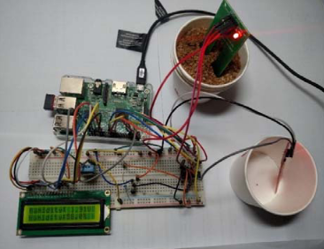

Step 10: Application Development
The final step in the IoT design methodology is to develop the IoT application.
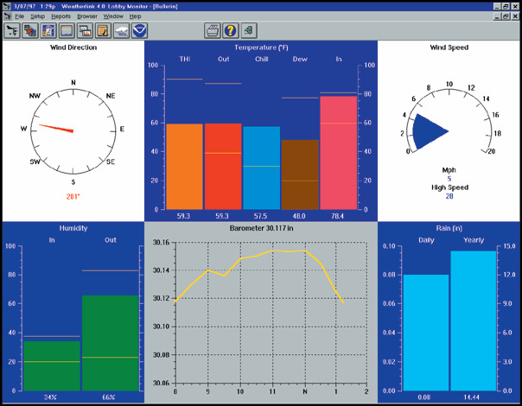

Conclusion:
The implementation of Weather Monitoring System is done with respect to the Iot design specifications provided above and the data insights are generated in the web based applications. The access to this data is accessible over the internet with the current level of implementation. This proposed system is the most suitable system for measuring weather conditions especially the areas suffering from vast pollutions.

